*University of Phoenix Material*

Creating a Class in Khan Academy

**Table of Contents**

* **How to set up your classes in Khan Academy**
* **Add Students to your Class**
* **Checking Student Progress**
* **Week 1 Checkpoint Objectives**
* **Required Khan Academy Study Plan Objectives**
* **Recommended Khan Academy Study Plan Objectives**

**How to set up your classes in Khan Academy**

As the instructor, you will need to create a profile in [Khan Academy](https://www.khanacademy.org/). Be aware that the look of the page may change but the steps will remain the same.

If this is your first time in Khan Academy, click on “Teachers start here,” (red box) as shown in the screen shot below. If you are returning to the website, simply log in to Khan Academy by clicking on the Sign In/Sign Up function, located on the top-right corner of your screen circled in purple.



Next, you will need to enter your name (first and last) and email address. Click on “Sign up” once you have completed these tasks. This step is shown below in the corresponding screen shot. *Note*: The image on the screen might change.



Next, you will receive an email to create a password. Once you have done so, login to the Khan Academy website. You will be then prompted to create a class. Click on “Create your class,” as shown below.

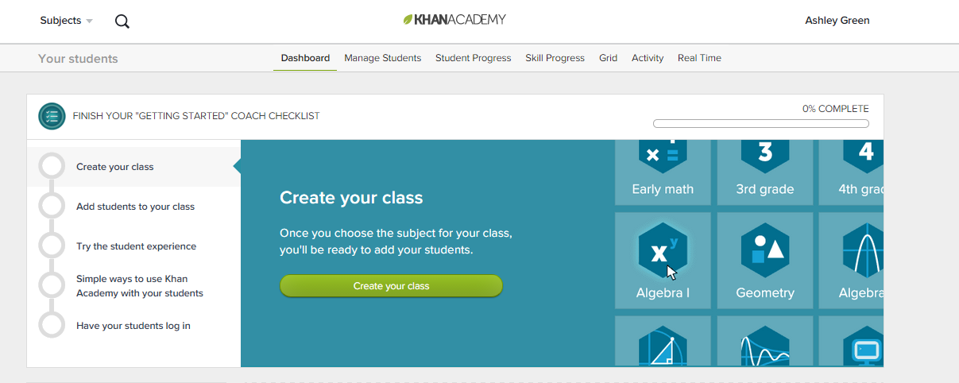

Give your class a name.

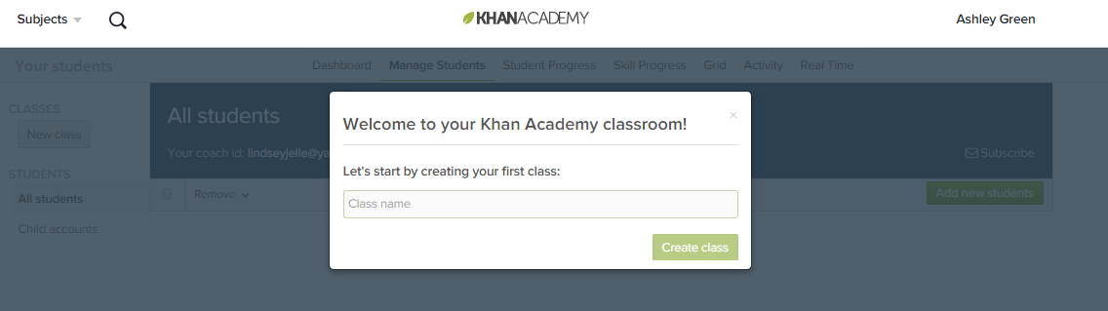

**[****Back to Top****]**

## Adding Students to your Class

Now is the opportunity to add new students. Simply click on “Add new students.”

Once you have completed these steps, click the “Add students with email” option. **Make sure your students are logging into the Khan Academy portal with their University of Phoenix e-mail credentials.** You might need to send out a private message (PM) to your students to confirm this. It is important to add them to your class. It is **highly recommended** that you send out a private message or make an announcement in Classroom to let students know they need to use their University email.

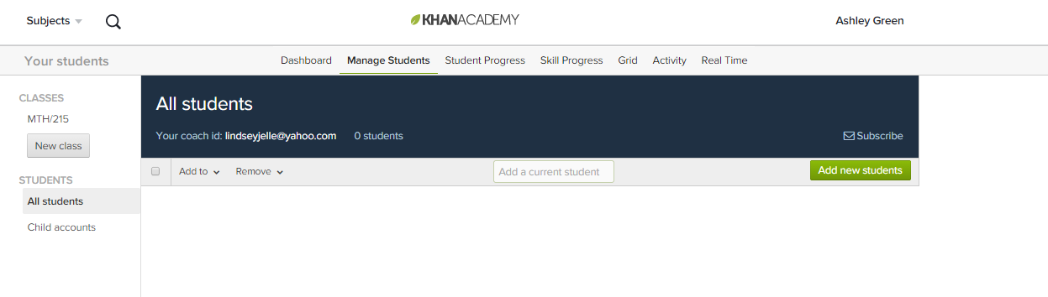

*Note*: These screens may change as Khan Academy often updates the look of their website.

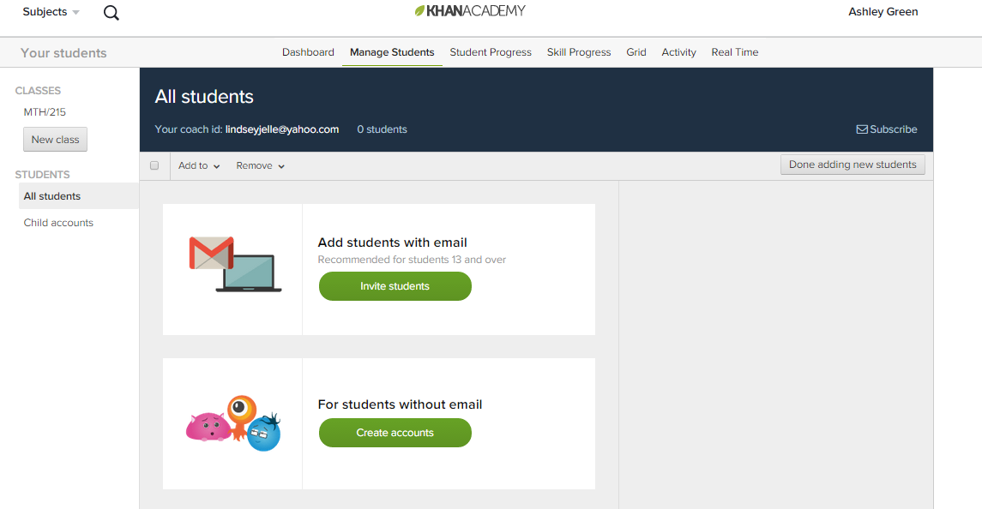

You will be prompted to invite them with their email address, so make sure to copy and paste their University of Phoenix e-mail addresses into the space provided. This will invite the students into the Khan Academy system in order for them to begin their Khan Academy missions.

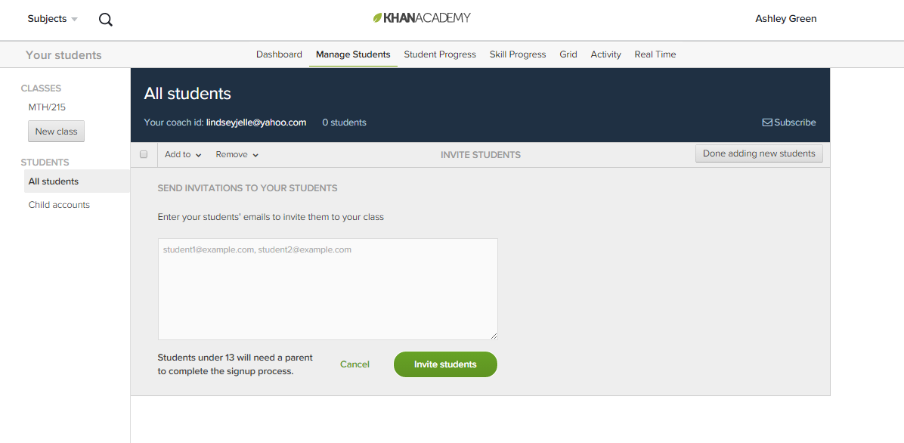

Once your students have accepted you as a coach or added you as a coach, you will then need to **add them to the class**. To add them to your class, click on your name in the top-right corner of the page and select “Your students,” as shown below.

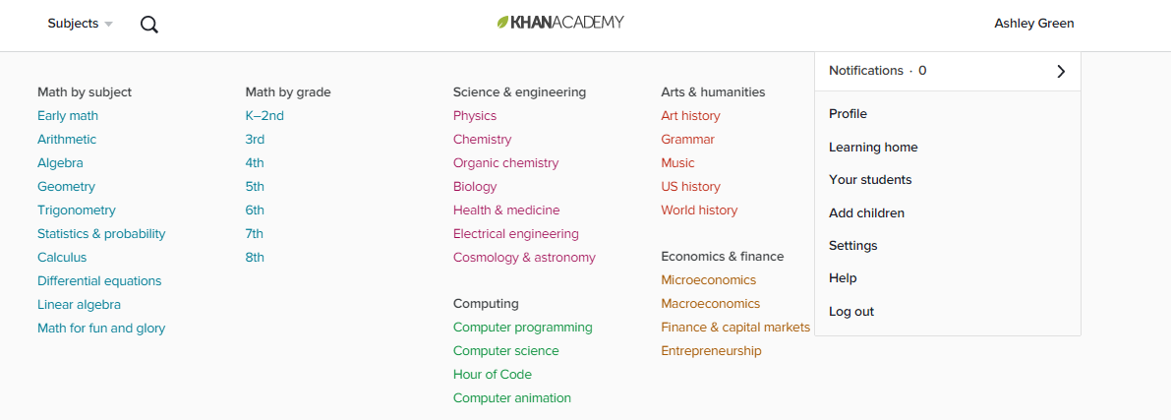

Select “Manage Class”.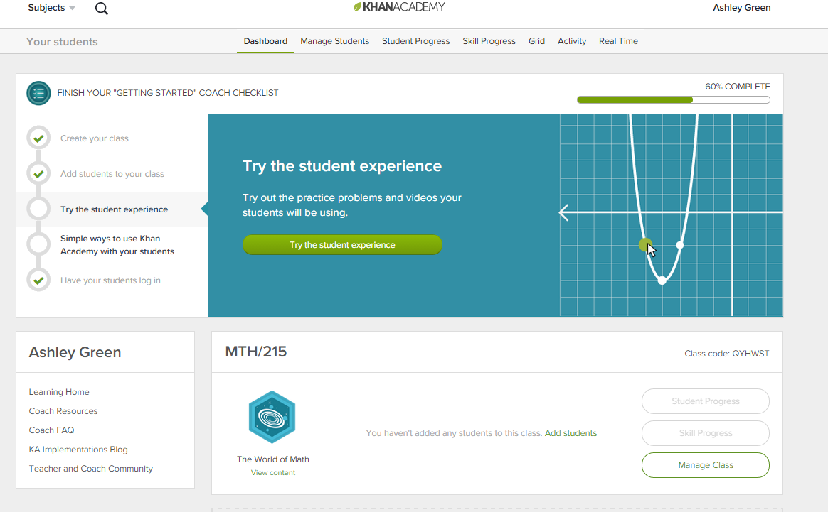

Then select “All students,” located on left-hand column under Students and select the students you would like to add to your class. **Click** on the “Add to” drop-down menu and select the course in which you would like to add these students.

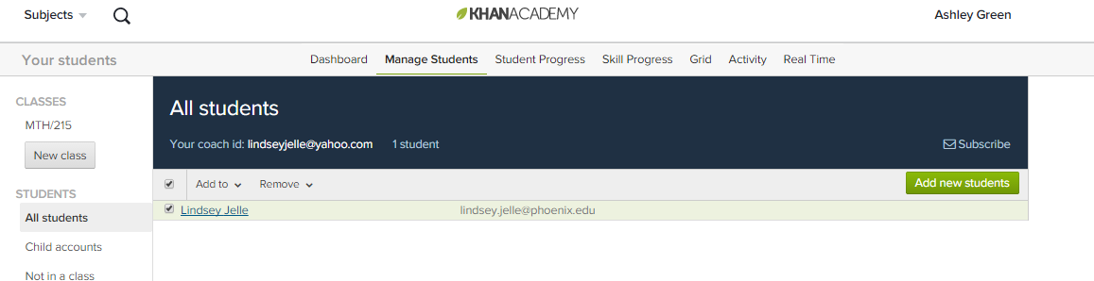

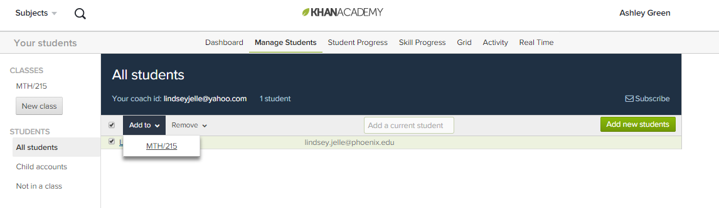

**[****Back to Top****]**

## Checking Student Progress

The students will be then be added to the course. From there, you can begin checking their progress by selecting the “Student Progress” tab, as shown below.

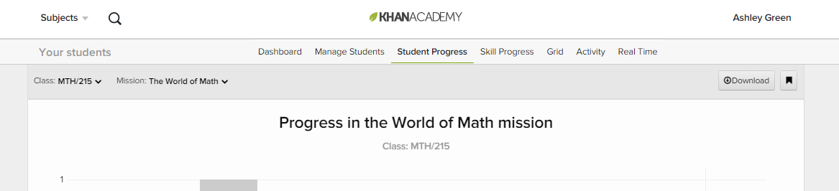

If you are at the home screen click on “Student Progress” of the class you would like to view as seen below.



To ensure you are only selecting the progress of specific course-related skills, you will need to click on the “Skills Progress” tab, as shown below.

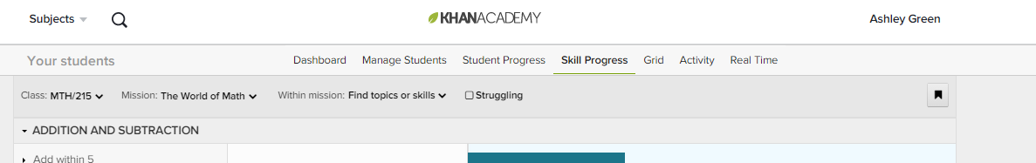

From there, select the “Mission” drop-down feature and then select” Algebra basics,” or whichever course you are tracking student progress.

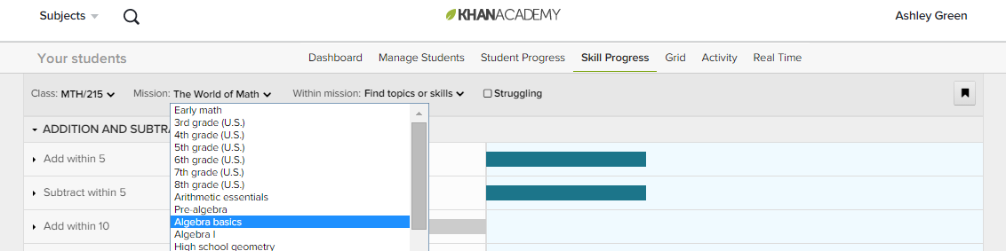

To view any of your student’s progress click on their name. This will bring up their mission progress. And show you what skills are mastered and where the rest of their skills fall. Be sure that Activity from All Time is selected at the top in case the student started working on their Khan Academy Study Plan before class started.

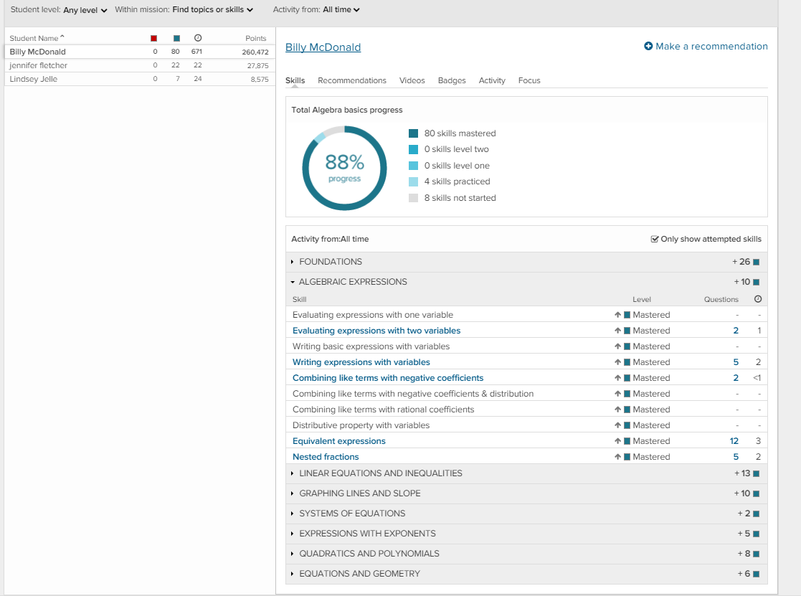

*Note*: These screens shots may change, but the steps will remain the same.

**[****Back to Top****]**

Week 1 Checkpoint Objectives

**Practice the items below** in the Khan Academy Study Plan before taking MyMathLab® Week 1 Checkpoint. Mastery is not required before completing the MyMathLab® Week 1 Checkpoint. However, it is recommended you master the items below before completing the Checkpoint to have the best chances of success. After you have completed these items continue on to the rest of the List of Required Objectives on the next page to achieve your 33% mission completion for Week 1.

**Foundations**

* Order of operations
* Order of operations with negative numbers
* Adding & subtracting negative fractions
* Multiplying positive and negative fractions
* Dividing positive and negative fractions

**Algebraic Expressions**

* Evaluating expressions with one variable
* Writing basic expressions with variables
* Writing expressions with variables
* Combining like terms with negative coefficients
* Combining like terms with negative coefficients & distribution

If you finish early with your 33% mission keep working on your mission. This will give you the best opportunity to fully complete your Khan Academy mission of 66%. If you do not finish your 33% mission in Week 1 keep working at it. You need these skills to be successful in this class and in your future career.

**[****Back to Top****]**

## Required Khan Academy Study Plan Objectives

**Foundations**

* Negative numbers on the number line
* Adding negative numbers
* Subtracting negative numbers
* Multiplying & dividing negative numbers
* Finding absolute values
* Interpreting absolute value
* Exponents
* Square roots of perfect squares
* Simplify square roots
* Simplify square-root expressions: no variables
* Rewrite decimals as fractions
* Finding percent’s
* Percent word problems
* Adding decimals: thousandths
* Subtracting decimals: thousandths
* Multiplying decimals 2 (standard algorithm)
* Dividing decimals: hundredths

**Algebraic Expressions**

* Evaluating expressions with two variables
* Combining like terms with rational coefficients
* Distributive property with variables

**Linear Equations and inequalities**

* One-step addition & subtraction equations
* One-step multiplication & division equations
* Two-step equations
* Two-step equations word problems
* Equations with variables on both sides
* Equations with parentheses
* One-step inequalities
* Two-step inequalities
* Two-step inequality word problems
* Multi-step linear inequalities
* Solving proportions
* Solving proportions 2
* Writing proportions
* Proportion word problems

**Graphing Lines and Slope**

* Graphing points & naming quadrants
* Intercepts from a graph
* Intercepts from an equation
* Slope from graph
* Slope from two points
* Graph from slope-intercept form

**Expressions with Exponents**

* Negative exponents
* Scientific notation
* Using exponent rules to evaluate expressions
* Properties of exponents

**Quadratics and Polynomials**

* Add polynomials
* Subtract polynomials
* Multiply monomials by polynomials
* Multiply binomials intro
* Multiply binomials
* Special products of binomials

**[****Back to Top****]**

## Recommended Khan Academy Study Plan Objectives

**Foundations**

* Area of triangles
* Radius, diameter, & circumference
* Area of a circle

**Algebra Expressions**

* Nested fractions
* Equivalent expressions

**Systems of Equations**

* Systems of equations with elimination challenge

**Graphing Lines and Slope**

* Solutions to 2-variable equations
* Complete solutions to 2-variable equations
* Slope-intercept equation from graph
* Slope-intercept equation from two points
* Graphs of two-variable inequalities

**Expressions with Exponents**

* Scientific notation challenge
* Multiplying & dividing in scientific notation

**Quadratics and Polynomials**

* Factor polynomials: common factor
* Factor quadratics: leading coefficient = 1
* Factor quadratics: leading coefficient ≠ 1
* Factor differences of squares
* Factor special products (basic)
* Factor perfect squares
* Solve quadratic equations by factoring: leading coefficient = 1
* Solve quadratic equations by factoring: leading coefficient ≠ 1

**Equations and Geometry**

* Find angles in triangles
* Pythagorean theorem
* Determine similar triangles: AA
* Determine similar triangles: SSS
* Solve similar triangles (basic)
* Solve similar triangles (advanced)

**Systems of Equations**

* Systems of equations with graphing
* Systems of equations with elimination
* Systems of equations with substitution
* Solve linear systems of equations

**[****Back to Top****]**